CHEMICAL ENGINEERING TRANSACTIONS  VOL. , 2023 | A publication of
The Italian Association
of Chemical Engineering
Online at www.cetjournal.it

Guest Editors: Laura Piazza, Mauro Moresi, Francesco Donsì
Copyright © 2023, AIDIC Servizi S.r.l.
ISBN 979-12-81206-01-4; ISSN 2283-9216

Investigation of an Energy-Saving System to Reduce the Energy Consumption of Decanter Machine
Claudio Peroneª, Antonio Berardiª, Cosimo Damiani Dellisantiª, Antonia Tamborrino^{a,}*, Alessandro Leoneª
ª Department of Soil, Plant and Food Sciences, University of Bari Aldo Moro, Via Amendola 165/A, Bari, 70126, Italy
antonia.tamborrino@uniba.it
This study presents a practical and simple approach to investigate the energy consumption of a decanter centrifuge during the sludge dewatering process. An experimental plan to measure the energy consumption of the decanter fed with sludge at three different flow rates and different differential speed values between bowl and screw (Δn) was carried out. The trend of the energy withdrawn from power supply as a function of the energy consumed by the bowl motor and the trend of the energy drawn from bowl motor as a function of that recovered from the regenerative braking system has been identified. Finally, the consumption of the bowl motor and of the energy taken from the mains as a function of the flow rate has been determined. The results show that the energy drawn from the grid and the energy regenerated by the regenerative braking system is linearly correlated with the energy consumed by the main electric motor and with the sludge feed rate. In addition, as the flow rate increases, the power recovered is about ¼ of that consumed. A high correlation of the developed models has been detected. The models developed can be used to provide valuable information about energy use patterns and can be used to identify areas where energy efficiency measures can be implemented.
  - Introduction
According to the International Energy Agency (IEA), the global electricity consumption in 2020 was about 22,315 TWh. This represents a decrease of about 1.5% compared to the previous year, primarily due to the COVID-19 pandemic and its impact on economic activity. The demand for electricity is expected to continue to grow in the coming years, driven by population growth, urbanization, and economic development (IEA. World Energy Outlook 2020, IEA. World Energy Model Documentation). However, the efforts to promote energy efficiency and increase the use of renewable energy sources can help to mitigate this growth and promote a more sustainable energy future (Sarkodie et al., 2020). The reduction of energy consumption can be effective only if a set of strategies are implemented in the energy use chain, which can be large-scale such as the use of energy from renewable sources to small-scale solutions such as optimizing plants of lighting (Qusay et al., 2023; Jun et al., 2020). To optimize the efficiency of the electric motors by reducing electricity consumption, a variable frequency drive (VFD) device can be implemented (Tan et al, 2020; Abdelsalam et al., 2022). A variable frequency drive (VFD) is an electronic device that can control the speed of an electric motor by varying the frequency of the electrical power supplied to the motor. VFDs can help to save energy in several ways:
- Energy efficiency: by adjusting the speed of the motor to match the load requirements, VFDs can reduce energy losses and improve the efficiency of the motor.
- Load management: VFDs can help to manage the load on a system by adjusting the amount of power supplied to the load, reducing the overall energy consumption.
- Soft starting: VFDs can provide a soft start to a motor, gradually increasing the speed and reducing the starting current, which can reduce stress on the motor and improve its lifespan.
A further function of the VFD is to control the electric motors by managing the regenerative braking. In fact the VFDs can be used to control motors that operate in applications where the motor may act as a generator, such as in centrifugal decanter machine. In these cases, the VFD can use regenerative braking of the screw of the decanter to convert the kinetic energy of the load into electrical energy, which can be fed back into the power grid, reducing energy consumption (Tamborrino et al., 2015). The decanter is a machine that performs the separation of solids from liquids by centrifugation and is used in many industrial fields and in the food industry (Squeo et al., 2017; Caponio et al, 2019; Tamborrino et al., 2022; Leone et al., 2022). In the sludge purification process, thickening or dewatering is a phase in which the sludge, coming from the purification cycles, is subjected, which aims to reduce the moisture present in the sludge itself. In purification plants, the dynamic thickening process by centrifugation with three-phase decanters is often used. In the present study, the energy consumption of a decanter machine during sludge dewatering processing in a waste purification industry has been analysed. A mapping of energy consumption was detected to evaluate the energy recovered by the regenerative braking system as a function of the investigated process parameters.
  - Materials and methods
    - Decanter machine
During the tests a three-phase decanter machine has been used. The main component of the decanter is a rotating body consisting of an external bowl with a cylindrical and conical shape and an internal screw (Leone et al., 2015). Bowl is driven by a 75 kW "Main Motor M1", while the screw is driven by the "Secondary Motor M2". Both motor M1 and motor M2 are equipped with variable frequency drive (VFD). The M2 VFD is of the regenerative type. Regenerative inverters allow energy to be recovered and poured into the grid, so that it can be used to power other equipment. The drive contains all the components needed to operate in regenerative mode, from the active power supply to the LCL line filter. The active power supply maintains full power flow in both motor and generation modes. During the process the VFD of the secondary motor M2, working in regenerative mode, through the connection that is defined as DC BUS in the machine diagram, recovers energy used to feed, totally or in part, the main motor M1. To evaluate the energy consumption of the decanter and investigate about the energy recovery of the regenerative braking system, a sludge dewatering test program was performed. Three different sludge feed rates were investigated from 15m³h⁻¹, 20m³h⁻¹ to 25m³h⁻¹ and for each flow rate the variation of the number of rotations between the drum and the screw (Δn) from 2.8 to 6.0 was adjusted.
    - Electricity consumption measurement system
Three compact energy meters LV001, LV002 and LV003 had been connected. Figure 1 shows the electrical diagram of the decanter and the position of the energy meters.

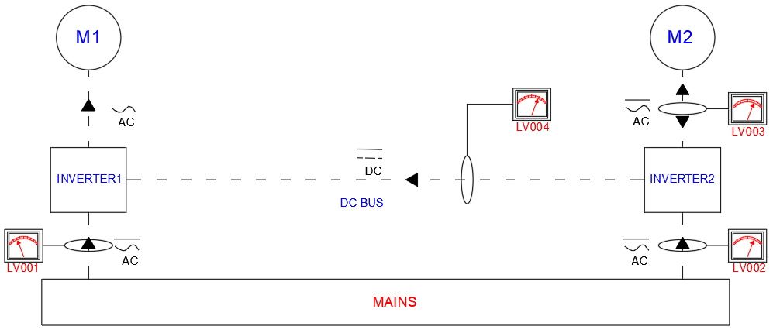
Figure 1 - Layout of the continuous energy monitoring system

The energy meters have been positioned as shown below:
- LV001 downstream of the inverter of the main motor M1;
- LV002 upstream of the inverter of the main motor M2;
- LV003 upstream of the inverter of the secondary motor M2.
By using a portable energy analyzer (LV004), the energy recovered from the regenerative system was measured on the DC BUS between the two VFDs. Each single measurement test lasted 60 minutes. Each individual test condition was repeated four times. TEmeter® software was used to manage the measurements. For the entire monitoring period, the main quantities of an electric network were detected with frequency per minute as averages of the previous 60 seconds. One measurement per minute was taken. During the measurement the following parameters was detected: a) Equivalent phase voltages and currents; b) Equivalent active and reactive power; c) Total displacement factor (cosφ); d) Frequency; e) Bidirectional active and reactive energy. In all tests the rotation speed of the bowl was 2600 RPM and the wastewater fed to the decanter had a percentage dry matter content between 1.1% and 1.7%. In all the tests carried out, 2.5% of liquid polymer was added to the inlet sludge.
  - Results and discussion
Figures 2, 3, Figures 4, 5 and Figures 6, 7 show for the flow rates of 15m³ h⁻¹, 20m³ h⁻¹ to 25m³ h⁻¹, respectively, the trend of the power withdrawn from power supply as a function of the power consumed by the main engine M1 and the trend of the power drawn from M1 as a function of that recovered from the regenerative braking system.

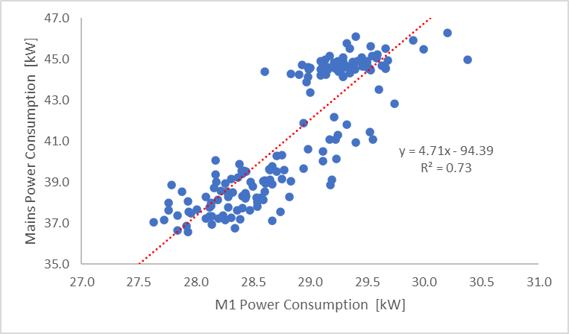 | 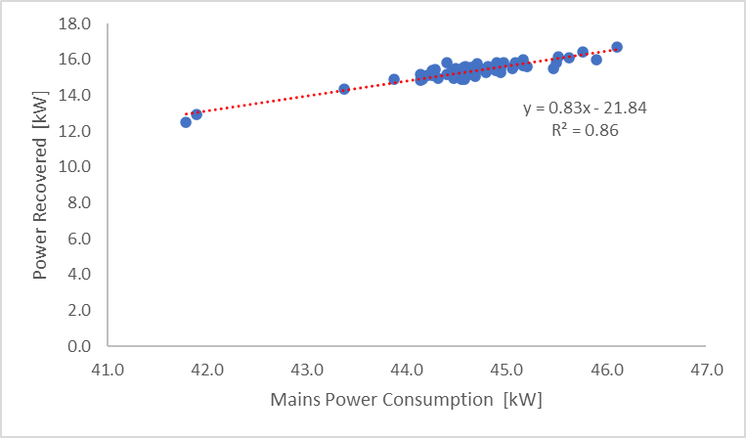
Figure 2 – Decanter flow rate 15 m³ h-1. Power consumption: mains vs M1 | Figure 3 - Decanter flow rate 15 m³ h-1. Power consumption: recovery vs mains
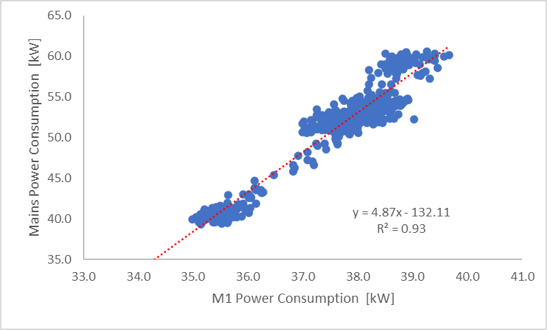 | 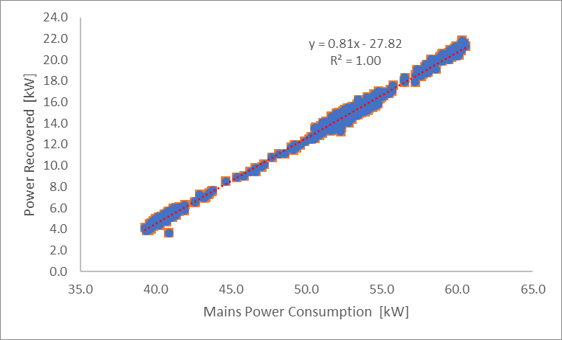
Figure 4 - Decanter flow rate 20 m³ h-1. Power consumption: mains vs M1 | Figure 5 - Decanter flow rate 20 m ³h-1. Power consumption: recovery vs mains
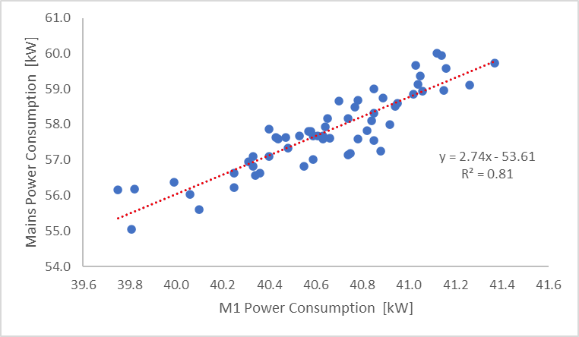 | 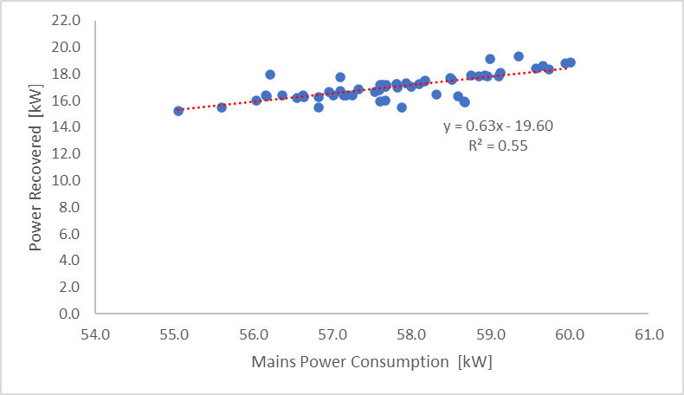
Figure 6 - Decanter flow rate 25 m³ h-1. Power consumption: mains vs M1 | Figure 7 - Decanter flow rate 25 m³ h-1. Power consumption: recovery vs mains

As shown in figure 2, 4 and 6, in all flow rate conditions the power drawn from power supply is a function of the power used by the main motor. This trend can be easily explained, in fact, considering the operating principle of the decanter, M1 drives the rotation of the bowl whose effort is proportional to the amount of sludge that stays inside it at a given instant. As reported in the experimental plan, the tests were carried out for each flow rate by varying the differential revolutions between the bowl and screw (Δn) increasing the flow rate, the Δn have been increased, consequently increasing the sludge discharge speed. Therefore, as the Δn increases, the quantity of sludge in the bowl decreases, lowering the rotational effort of the M1 and therefore its power consumption and consequently the withdrawal of power from the main supply and the power recovered. Between power consumption of the M1 and withdrawal from the power supply, a strong linear correlation was identified with a coefficient of correlation R² always greater than 0.81, confirming the effectiveness of the identified model.
Similarly, as shown in figures 3, 5 and 7, the amount of power recovered is also a function of the one used by the M1 at all three investigated flow rates. This means that the higher the power consumption of the M1, the higher will be the quantity of wastewater present inside the bowl at a given instant, consequently the VFD can use a greater regenerative braking of the screw of the decanter converting the kinetic energy of the load into electrical fed back into the power grid. Between power recovered and one used by the main engine a strong linear correlation was identified with R² always higher than 0.86
In Figure 8, the withdrawal from the main grid as a function of flow rate is shown and a linear growth trend between decanter flow rate and power withdrawal from the mains with average values of 28.8 kW at 15m³ h⁻¹, 37.4 kW at 20m³ h⁻¹ and 40.7 kW at 25m³ h⁻¹. This trend confirms what previously reported, in fact the higher the decanter flow rate, despite optimizing the relative value of Δn, the higher the amount of wastewater presents in the bowl. Consequently, it is necessary an increasing of the effort of the main motor, whit a higher total amount of power drawn from the grid. The R² of 0.84 confirms the goodness of the developed model.

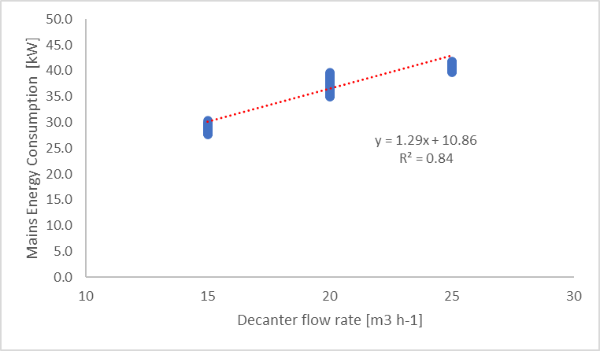 | 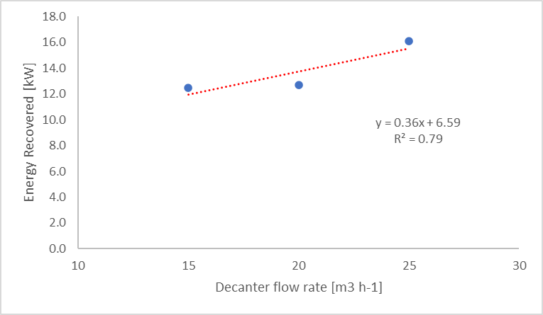
Figure 8 - Decanter flow rate vs Mains power consumption | Figure 9 - Decanter flow rate vs Power recovery

In Figure 9, the trend of the power recovered from the regenerative braking system grows linearly with the increase in the decanter feed flow rate. As mentioned earlier the VFD of the motor driving the screw is regenerative braking, which allows it to recover power, up to 4 kW increasing M1 power consumption of 12 kW, during the deceleration of the motor and feed it back into the power supply. As the flow rate increases, the amount of sludge in the bowl increases, increasing the power regenerative capacity. The high correlation coefficient (R² of 0.79) demonstrates the goodness of the trend developed. Finally, comparing the slopes of the lines in Figures 8 and 9, it is highlighted that from 15m³h⁻¹ to 25m³h⁻¹ the power consumed of M1 increases by about 12 kW, while the recovery by only 3-4 kW. This means that as the flow rate increases, the power recovered is about ¼ of that consumed. The approach to energy consumption prediction based on time series analysis, until develop the trends in energy consumption data has proven to be an effective way to understand the energy consumption of a machine as reported by several authors (Xie et al, 2021; Lee et al., 2015; Imani et al., 2017; Liu et al., 2015; Perone et al., 2022; Tamborrino et al., 2021; Catalano et al., 2021).
  - Conclusions
Energy consumption and sustainability are closely linked, as the way we consume energy has a significant impact on the environment and the long-term availability of energy resources. Among the various solutions proposed to reduce the energy consumption of industrial machines driven by electric motors is the use of variable frequency drives. Whenever the working mode of the machine allows it, the VFD can operate in regenerative braking way, which allows them to recover energy during the deceleration of the motor and feed it back into the power supply. However, the relationship between energy consumption and machine regulation methods are almost always unknown to the process planner who, in the absence of such information, uses the machine in an inefficient way. Energy consumption modeling makes it possible to discover these relationships by making them available to the process planner. The developed models can be utilized by the process planners to identify the most energy-efficient based process plan before the sludge dewatering machining. Further, in future, to obtain an even broader picture of information the proposed model could be integrated with the productivity and product quality models. In this way, the process planner will be able to evaluate the correct adjustment of the machine to reduce energy consumption based on the proposed production and quality objectives.
Acknowledgments
The authors have contributed to the same extent to the present study.
References
IEA. World Energy Outlook 2020. Paris: IEA Publishing; 2020.
IEA. World Energy Model Documentation. IEA Publishing; Paris. 2020. https://www.iea.org/reports/world-energy-model (accessed March 26, 2021).
Sarkodie, S.A., Adams, S., & Leirvik, T., 2020. Foreign direct investment and renewable energy in climate change mitigation: does governance matter? J. Clean. Prod. 263, 121262.
Qusay, H., Al-Hitmi, M., Tabar, V. S., Sameen, A. Z., Salman, H. M., & Jaszczur, M., 2023. Middle East energy consumption and potential renewable sources: An overview. Cleaner Engineering and Technology, Volume 12, 100599, ISSN 2666-7908. https://doi.org/10.1016/j.clet.2023.100599.
Jun, Z., Wang, Z., Ankai, C., Jinkang, Y., Yicheng, R., Chen, Z., Wu, J., Wei, L., Bing, B., Wei, W., & Zhongwei, Z., 2020. Sustainability of unconventional machining industry considering impact factors and reduction methods of energy consumption: A review and analysis. Science of The Total Environment, Volume 722, 137897, ISSN 0048-9697. https://doi.org/10.1016/j.scitotenv.2020.137897.
Tan, C., Zi-Ming, F., Liu, X., Fan, J., Cui, W., Sun, R., & Ma, Q., 2020. Review of variable speed drive technology in beam pumping units for energy-saving. Energy Reports, Volume 6, pp 2676-2688, ISSN 2352-4847. https://doi.org/10.1016/j.egyr.2020.09.018.
Abdelsalam A. A., Moharam, B. A., & Rashad, E. E., 2022. Improving energy efficiency and economics of motor-pump-system using electric variable-speed drives for automatic transition of working points. Computers & Electrical Engineering, Volume 97, 107607, ISSN 0045-7906. https://doi.org/10.1016/j.compeleceng.2021.107607.
Tamborrino, A. Leone, A., Romaniello, R., Catalano, P., &Bianchi, B., 2015. Comparative experiments to assess the performance of an innovative horizontal centrifuge working in a continuous olive oil plant. Biosystems Engineering, Volume 129, pp 160-168, ISSN 1537-5110. https://doi.org/10.1016/j.biosystemseng.2014.10.005.
Squeo, G., Tamborrino, A., Pasqualone, A., Leone, A., Paradiso, V., Summo, C., & Caponio, F, 2017. Assessment of the Influence of the Decanter Set-up During Continuous Processing of Olives at Different Pigmentation Index. Food and Bioprocess Technology. 10. 10.1007/s11947-016-1842-7.
Caponio, F., Leone, A., Squeo, G., Tamborrino, A., & Summo, C., 2019. Innovative technologies in virgin olive oil extraction process: influence on volatile compounds and organoleptic characteristics: Influence of innovative technologies on sensory notes of virgin olive oils. Journal of the Science of Food and Agriculture. 99. 10.1002/jsfa.9856.
Tamborrino, A., Perone, C., Veneziani, G., Berardi, A., Romaniello, R., Servili, M., & Leone, A., 2022. Experimental Investigation of a New Modular Crusher Machine Developed for Olive Oil Extraction Plants. Foods (Basel, Switzerland), 11(19), 3035. https://doi.org/10.3390/foods11193035
Leone, A., Tamborrino, A., Esposto, S., Berardi, A., & Servili, M., 2022. Investigation on the Effects of a Pulsed Electric Field (PEF) Continuous System Implemented in an Industrial Olive Oil Plant. Foods (Basel, Switzerland), 11(18), 2758. https://doi.org/10.3390/foods11182758
Leone, A., Romaniello, R., Zagaria, R., & Tamborrino, A., 2015. Mathematical modelling of the performance parameters of a new decanter centrifuge generation. Journal of Food Engineering. 166. 10.1016/j.jfoodeng.2015.05.011.
Xie, J., Cai, W., Du, Y., Tang, Y., & Tuo, J., 2021. Modelling Approach for Energy Efficiency of Machining System Based on Torque Model and Angular Velocity. Journal of Cleaner Production. 293. 126249. 10.1016/j.jclepro.2021.126249.
Lee, J.Y., Shin, Y.J., Kim, M.S., Kim, E.S., Yoon, H.S., Kim, S.Y., Yoon, Y.C., Ahn, S.H., & Min, S., 2015. A Simplified Machine-Tool Power-Consumption Measurement Procedure and Methodology for Estimating Total Energy Consumption. Journal of Manufacturing Science and Engineering. 138. 10.1115/1.4031713.
Imani, A.R., Newman, S.T., & Nassehi, A., 2017. A mechanistic model of energy consumption in milling. Int J Prod Res;56:642–59. https://doi.org/10.1080/ 00207543.2017.1404160.
Liu, F., Xie,J., & Liu S., 2015. A method for predicting the energy consumption of the main driving system of a machine tool in a machining process. J Clean Prod, 105: 171–7. https://doi.org/10.1016/j.jclepro.2014.09.058.
Perone, C., Romaniello, R., Leone, A., Berardi, A., & Tamborrino, A., 2022, Towards energy efficient scheduling in the olive oil extraction industry: Comparative assessment of energy consumption in two management models. Energy Conversion and Management: X, Volume 16, 100287, ISSN 2590-1745. https://doi.org/10.1016/j.ecmx.2022.100287.
Tamborrino A., Catalano F., Berardi A., Bianchi B., 2021, New Modelling Approach for the Energy and Steam Consumption Evaluation in a Fresh Pasta Industry, Chemical Engineering Transactions, 87, 409-414.
Catalano F., Bianchi B., Berardi A., Leone A., Tamborrino A., 2021, Experimental Trials and Dynamical Simulation of the Potential Biogas Production in a Frozen Food Industry, Chemical Engineering Transactions, 87, 295-300.

